
The Well-being of Future Future Generations Act and the Commissioner.

Survey results


October 2025

Preface.
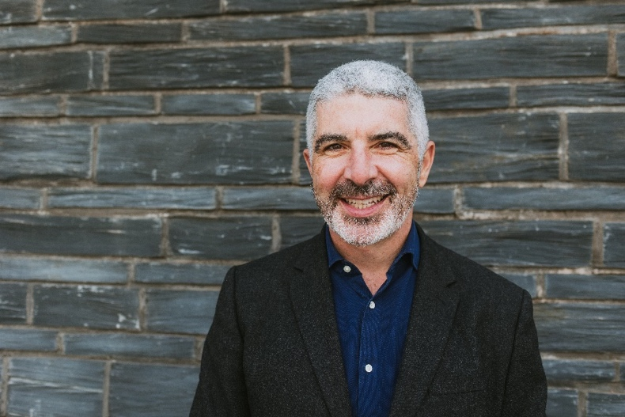
As we mark ten years since the Well-being of Future Generations (Wales) Act became law, it is important to reflect on how far we have come in the last decade and consider the path yet to come.
This survey about the Act is the first of its kind and has provided an opportunity to gather meaningful feedback from a diverse range of stakeholders to assess awareness and understanding of the legislation, gather stories of its impact, and consider its challenges.
The answers reveal that stakeholders have a good understanding of the Well-being of Future Generations Act, with almost 80% having a good understanding and just 4% saying they have never heard of it. In terms of professional impact, 85% of respondents have given a score of at least three out of five, indicating that the vast majority believe the Act has had an impact on their work or organisation.
Over 75% of respondents demonstrated at least a fair degree of awareness of the work of my office, scoring at least three out of a possible five. Only 7% opted for the lowest score of one, suggesting that very few stakeholders have no awareness. I was pleased that my office scored well on favourability, with 86% of respondents scoring at least three out of five for a favourable impression of my work and that of my team.
There are areas where we can improve. This survey will support accountability and continuous improvement, ensuring that the work of my team grows to be even more relevant, impactful, and aligned with the needs of current and future generations in Wales. With ten years of experience, it is now time to review the Act to make it stronger to respond to the challenges and opportunities ahead.
I would like to thank everyone who participated in the survey and I look forward to working with you to deliver on the implementation of the Act.
Over the last decade the Act has made a significant impact. People are rightly proud in Cymru to have this approach to improving well-being and planning long-term. The Act is essential for the future of Wales.

Derek Walker
Future Generations Commissioner for Wales

Contents.

Executive Summary. 4
Introduction. 5
Methodology. 6
Respondents 6
Engagement with the Act. 8
Further Commentary 9
The Commissioner and his Team. 14
Priorities and Work Programme 17
Additional Support 19
Further Investigations 23
Visibility of the Commissioner and his Team 27
Conclusion. 29

Executive Summary.

This report presents the findings of a comprehensive stakeholder engagement survey conducted to assess awareness, understanding, and impact of the Well-being of Future Generations (Wales) Act, ten years after its introduction.
The survey gathered responses from a broad cross-section of stakeholders, including representatives from local authorities, the Senedd, health boards, voluntary organisations, and the private sector.
Nearly 80% of respondents report a good understanding of the Act, and 85% believe it has influenced their work or organisation. The Act is widely recognised as a strategic framework, shaping organisational culture and long-term thinking, especially within the public sector.
While many respondents describe the Act as transformative and inspirational, others see its implementation as uneven. Some organisations have deeply embedded the Act in their processes, while others treat it as a compliance exercise with limited practical impact.
The most frequently cited barriers are short-term funding cycles, bureaucracy, and a perceived lack of enforcement. These issues are particularly acute in local government, health, and the voluntary sector, where resource constraints undermine long-term planning and service delivery.
Stakeholders consistently call for more practical, sector-specific guidance, case studies, and training. There is a strong appetite for workshops, peer learning, and resources that translate the Act’s ambitions into everyday action.
Respondents emphasise the importance of policies that promote resilient and inclusive communities, tackle poverty, and facilitate regeneration. Environmental sustainability, climate resilience, and biodiversity are dominant concerns, with calls for more ambitious action on carbon reduction and natural resource management.
There is a clear desire for greater integration between health and social care, improved public transport, and better support for vulnerable groups. Education, skills, and employment are identified as areas where the Act could have a greater influence.
Over 75% of respondents have a favourable impression of the Commissioner and the team, with strong scores for communication, engagement, and focus on the right issues. However, some stakeholders remain less engaged or lack sufficient information, indicating room for improved visibility and outreach.
In summary, the Well-being of Future Generations Act is valued and supported in principle, but requires more practical support, sustainable funding, and a renewed focus on outcomes to fulfil its promise for the people of Wales.

Introduction.

This report presents the findings of a comprehensive online survey conducted to assess awareness, understanding, and impact of the Well-being of Future Generations (Wales) Act, ten years after its introduction as well as an assessment of the work of and engagement with the Commissioner and his team. The survey ran online from 29th September to 17th October 2025 and was fully bilingual, accessible in both Welsh and English.
Over 200 responses were received from across Wales, representing a broad cross-section of stakeholders. Respondents included representatives from local authorities, the Senedd, health boards, voluntary organisations, and the private sector. The survey was widely promoted via direct email invitations, stakeholder networks and social media platforms, ensuring a diverse and inclusive range of perspectives.
The survey combined quantitative questions with open-ended commentary, allowing for both statistical analysis and rich qualitative insights. This approach enabled the collection of detailed feedback on the Act’s impact, challenges, and opportunities, as well as suggestions for future action by the Future Generations Commissioner and the team.

Methodology.

The stakeholder engagement survey was accessible online for three weeks via two survey links, one in each language.
Stakeholders, including Senedd Members, Members of Parliament and local authority councillors, were sent direct links via email to the two surveys. It was also shared with a wide variety of stakeholders from public sector organisations, such as national park authorities, health boards, and fire and rescue services. The links were also circulated to a contact list including private individuals, workers in the private sector, academia, as well as a significant number of voluntary sector organisations.
The survey links were also shared on multiple social media platforms by both the Office of the Future Generations Commissioner and Cavendish Consulting. The platform with the most significant interaction was LinkedIn.
The survey included a mix of closed and open-ended questions, allowing for both quantitative analysis (e.g. scored responses on a sliding scale) and qualitative insights (e.g., detailed comments, opinions and suggestions). No contact details were collected, although some respondents chose to provide their name and/or postcode.
The responses were analysed using a combination of statistical methods and thematic analysis, ensuring that both the breadth and depth of stakeholder opinion were captured.

Respondents
The 213 responses displayed a variety of public, private and voluntary sector backgrounds, but most respondents were county councillors on Welsh unitary authorities. The graph below shows the organisation to which each respondent belongs.
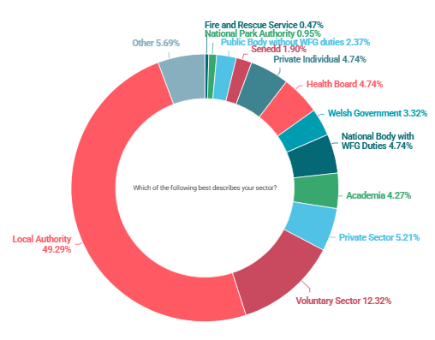

Of the 104 who answered ‘Local Authority’ as their sector, 72 did not give a role, but 7 gave their role as local authority councillor, 24 gave their role as officer or other staff member, and one gave their role as senior director. Of those who gave their sector as ‘Senedd’, this included two Senedd Members and two Senedd staff members.

Engagement with the Act.

The first set of questions was about the Well-being of Future Generations Act. Respondents were asked how familiar they are with the Act and asked to score their level of understanding from ‘I’ve never heard of it’ to ‘I am an expert on the Act’. Secondly, respondents were asked how much impact or influence they think the Act has had on them, their work or their organisation.

Q1: How familiar are you with the Well-being of Future Generations Act?

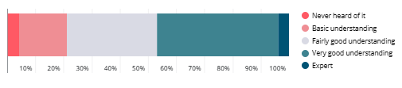

Q2: In the primary capacity in which you are filling out this survey, how much impact or influence do you think the Act has had on you, your work or organisation? (1 being no impact at all, 5 being significant impact)
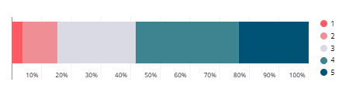

These answers reveal that stakeholders generally have a good understanding of the Well-being of Future Generations Act, with almost 80% having a good understanding and just 4% saying they have never heard of it (Q1).
In terms of professional impact, 85% of respondents have given a score of at least three out of five, indicating that the vast majority believe the Act has had an impact on their work or organisation (Q2).

Further Commentary
Respondents were given the opportunity to provide further detailed commentary on their answers. There were 128 open responses. A summary of the key findings is below.

Overall Sentiment:
- Positive sentiment: Approximately 60% of respondents expressed positive views about the Well-being of Future Generations (Wales) Act, highlighting its inspirational value, strategic importance, and its role in shaping organisational culture and long-term thinking.
“The Act has had a significant and multi-dimensional impact on the organisation, shaping both strategic direction and operational culture.” (National Body with duties under the WFG Act)
- Negative sentiment: Around 30% of responses were negative, focusing on issues such as bureaucracy, lack of enforcement, superficial implementation, and funding constraints.
“We have to justify every decision using the act. It slows down action and most of it was being done anyway. Increases bureaucracy and adds cost.” (Local Authority)
- Neutral or mixed sentiment: The remaining 10% were neutral or mixed, either expressing limited awareness or describing both positive and negative aspects.
“I have a basic understanding and have been able to relate some of this information to the work I do, but I wouldn't say it's featured specifically in my role.” (Local Authority)

Strategic Alignment and Organisational Embedding
The Well-being of Future Generations Act (WFG Act) is described by more than 30 respondents as a foundational framework that guides organisational strategy, governance, and daily operations. In some organisations, especially within the public sector, the Act is deeply embedded in procurement, reporting, policy development, and performance review.
The Act is widely referenced as a strategic framework across public, voluntary, and some private sector organisations. In many cases, it shapes policies, reporting, and decision-making, and is seen as a driver for long-term thinking and collaboration. However, the extent of integration varies: some organisations have deeply embedded it, while others treat it more as a compliance requirement or a symbolic reference, with limited impact on day-to-day practice.
“All council reports have a section on the Act to show that it has been considered, but I do not know whether any recommendations presented have in reality been modified because of the Act.” (Local Authority)
“The Authority's Well-being Objectives frames the corporate priorities of the organisation linked to Climate, Conservation, Connection and Communities. It also influences wider areas such as planning. As a result, it feeds through to our performance frameworks and also to risk management.” (National Park Authority)

Operational Impact and Practical Implementation
The Well-being of Future Generations Act (WFG Act) is described by around 30 respondents as a foundational framework that guides organisational strategy, governance and daily operations. In some organisations, especially within the public sector, the Act is deeply embedded in procurement, reporting, policy development, and performance review.
However, the depth of integration varies. Some view the Act as transformative, genuinely shaping culture and decisions, while others perceive it as more symbolic, limited to documentation or compliance. For instance, a local authority officer remarks, “All council reports have a section on the Act to show that it has been considered, but I do not know whether any recommendations presented have in reality been modified because of the Act.” This highlights a tension between the Act’s intended influence and its actual impact.
“At least half of us are now working in a completely different way, and the results are much better than they used to be.” (Welsh Government)
“At the start of every meeting, it gets trotted out as a mantra, as by law it has to be said, but there is therefore a sort of lip service approach to the Act—it has rarely been referred to again in the main body of a meeting.” (Other public sector organisation)
“It has had an impact, but not necessarily in the intended way, or even a positive way. The council spends a good amount of time and money producing poor quality boilerplate assessments to comply with the act, in a way which does not meaningfully contribute to policy making but comes at cost to the public purse.” (Local Authority)

Challenges: Funding, Bureaucracy, and Enforcement
A recurring theme is the challenge of limited funding, increased bureaucracy, and a perceived lack of enforcement mechanisms, with around 30 respondents highlighting practical barriers to effective implementation. Short-term funding cycles, administrative burdens and limited staff engagement are common issues. Many feel that compliance with the Act can become a bureaucratic exercise, detracting from meaningful change. There is a desire for the Act to have stronger enforcement and for resources to match its ambitions.
“Budget constraints prevent us from doing more.” (Local Authority)
“Whilst the idea and principles of the Future Well-Being Act are welcomed and endorsed, it is not having much visual impact due to a lack of additional funding for local authorities to use on specific projects and improvements in their towns and cities.” (Local Authority)
“The Act has few enforcement teeth with it, and everyone knows this, and parts can be contradictory.” (Other public sector organisation)

Collaboration and Partnership Working
The Act is credited with encouraging more joined-up working across sectors, especially through Public Services Boards (PSBs). Collaboration is valued for tackling complex issues, but respondents note that partnership structures and leadership vary in effectiveness. The third sector and communities often feel underutilised or peripheral in decision-making, and there is a call for more inclusive and effective partnership models.
“Collaboration across health and social care services. Refocusing funding allocation on preventative solutions and early intervention in community settings.” (Public Body without duties under the WFG Act)
“The Act has increased public sector awareness of involvement and encouraged a growing willingness to engage in co-production and collaboration, particularly with PSB officers.” (Voluntary Sector)
“There is a clear and encouraging commitment across the region to working in partnership and adopting whole-system approaches, but fully addressing these inequalities requires an informed understanding of how they operate within a rural context, and how cross-sector collaboration and action across all levels of prevention are essential to making long-term changes.” (Health Board)

Focus on Well-being Goals: Health, Housing, Environment, and Inequality
Key well-being goals, such as health, housing, environmental sustainability, and reducing inequality, were mentioned by nearly 40 respondents. The Act provides a useful lens for addressing these challenges; however, progress is often slow and hindered by conflicting priorities and resource constraints. Respondents want more joined-up, place-based approaches and practical solutions to these pressing issues.
“Provision and use of sports/recreational facilities, especially by children and young people. I'd dearly love to see a join-up between food policy and health policy in government at all levels.” (Local Authority)
“Nature emergency – see my response to the last question. More focus on long-term thinking and legacy. Relationship with Net zero and nature recovery. Community cohesion.” (Local Authority)
“Social disparity and cohesion.” (Local Authority)

Need for Practical Guidance, Case Studies, and Knowledge Sharing
There is strong demand for practical examples, case studies, and opportunities to share best practice. Around 25 respondents referred to the need for guidance that is actionable and relevant to their sector, rather than theoretical or generic. Dynamic sharing of data and insights is considered important for supporting implementation and learning from others.
“Sharing of good, embedded practice, not just new and innovative ideas, but also getting the basics right.” (Local Authority)
“There is too much guidance, and it is too wordy. There needs to be more space & time for practical face-to-face sessions to share good practice & learn together.” (Voluntary Sector)
“I have used the three horizons model, and that was helpful, but I think more examples and case studies of what works. Being theoretical is one thing, but working pragmatically on the ground in a busy environment is another.” (Health Board)

Perceived Gaps: Awareness, Communication, and Enforcement
Awareness of the Act and the Commissioner’s office is uneven, with some respondents (fewer than 20) unaware of their existence or role. Communication is perceived as insufficient, and concerns exist about the Act’s lack of enforcement. Many call for greater visibility, clearer messaging, and stronger mechanisms to ensure consistent application and impact.
“I was not aware of the guidance before taking this survey.” (Local Authority)
“Lack of Communication, so no idea what the Commissioner and team are up to.” (Local Authority)
“I’ve no idea what the act is or where to find it. Therefore, I cannot comment on its effect on me.” (Local Authority)

Sector-Specific Issues and Innovations
Different sectors highlight unique challenges and innovations. The voluntary sector focuses on inclusion and creative projects, while the private sector seeks more engagement. Health and education respondents emphasise the need for joined-up approaches and tailored support. There is recognition of the Act’s potential to drive change, but also a call for more sector-specific guidance and resources.
“We worked with the FGC office to develop our sustainability strategy and continue to engage on its implementation; we still have work to do on engaging the wider organisation with the act.” (Other public sector organisation)
“The impacts of AI in the workplace and on the workforce. Upskilling of the workforce and a just transition. The worker voice in sustainable development.” (Other public sector organisation)
“Organic food production, rural economy and rural housing opportunities for young people ... Thinking about OPD or TAN6 agricultural tied business properties as options for young people to build and own affordable homes.” (Private Individual)

Functional Variation
Given that most respondents had identified the nature of their role and the type of organisation they work for, we undertook an analysis to gauge whether there was a different response based on function. We wanted to investigate whether the type of organisation and role lead to different responses, and whether these responses are more positive or negative.
Representatives of local authorities had the most mixed responses about the Act. Only 38% were positive about it, compared to those in the private sector, the Welsh Government, and academia, who scored a positivity rate of around 60%. Some 50% of those in the voluntary sector were positive about the Act.
- Responses from the public sector are more mixed, with a significant proportion of both positive and negative sentiment, particularly amongst respondents from local authorities. Positive responses often mention strategic alignment and long-term thinking, while negative responses cite bureaucracy, funding constraints and lack of impact. Welsh Government staff are mostly positive, focusing on the Act’s framework and ambition, but some note challenges in embedding it operationally. A majority of academics express a positive sentiment, particularly regarding the Act’s potential for positive change, while also highlighting the need for more training, practical application, and increased awareness.
Some informal feedback suggested that some officers from public bodies were worried about attributing their names or their organisations. This has likely resulted in a disproportionately high response rate from elected representatives, who might be more likely to be sceptical of the Act and more comfortable going on the record with their views.
- Voluntary sector senior officers tend to be more positive, highlighting the Act’s inspirational value and its role in shaping organisational culture. The results also suggest that voluntary sector respondents tend to be proactive in seeking information and engaging with the Commissioner’s office, often through online searches and regular meetings.
- Private sector respondents tended not to engage with the open question, so it is difficult to draw conclusions, but perhaps this suggests less engagement with the Commissioner and his team.

Summary
The Well-being of Future Generations (Wales) Act is widely recognised as a progressive and ambitious piece of legislation. It has shaped strategic thinking and provided a framework for collaboration, sustainability, and long-term planning. However, its operational impact is uneven, with challenges around funding, bureaucracy, and enforcement.
While many find it inspirational, others are frustrated by its lack of tangible outcomes. There is a clear call for deeper embedding, more training, and stronger mechanisms to ensure its principles translate into meaningful change.

The Commissioner and his Team.

In the second section, respondents were asked a series of questions about their awareness and overall impression of the Commissioner and his team.

Q4: On a scale of 1 to 5, how would you rate your awareness of the Future Generations Commissioner for Wales and his team? (1 being not aware at all, 5 being very aware)
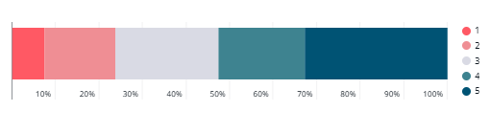

Q5: How favourable is your overall impression of the Future Generations Commissioner for Wales and his team? (1 being not favourable at all, 5 being very favourable)
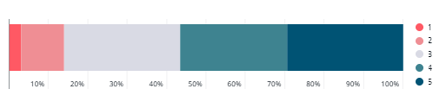

Over 75% of respondents demonstrated at least a fair degree of awareness of the Commissioner and his team, scoring at least three out of a possible five (Q4). Only 7% opted for the lowest score of one, suggesting that very few stakeholders have no awareness. The Commissioner scored slightly higher on favourability (Q5) than awareness, with 86% of respondents scoring at least three out of five for a favourable impression of the Commissioner and his team. This suggests there is room for growth in promoting the Commissioner’s work, so while favourability is high, stakeholders may wish to be better informed about the Commissioner’s role and work.

The next series of questions asked respondents to agree or disagree to a series of statements about the Future Generations Commissioner and his team.

Q6: How would you respond to the following statements: The Future Generations Commissioner for Wales and his team…

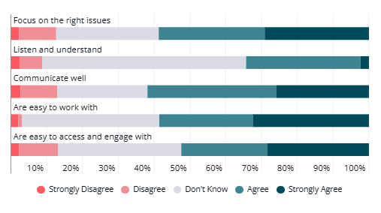

In summary, the results reveal a broadly positive perception among stakeholders of their engagement with the work of the Commissioner and his team (Q6). Over 60% either agreed or strongly agreed with ‘communicates well’, which scored the highest for positivity of the five statements. The statement with the lowest negative score was ‘are easy to work with’, with just 4% either strongly disagreeing or disagreeing, which suggests the Commissioner and his team are succeeding at building positive relationships with partners and other stakeholders.
The most significant proportion of ‘don’t knows’ was in response to the statement about listening and understanding, and perhaps this is a more difficult question for stakeholders to answer unless they have worked with the Commissioner and his team particularly closely. The percentage of ‘don’t knows’ suggests there remains a segment of stakeholders who are less engaged or lack sufficient experience to form an opinion.
Overall, more than 50% of stakeholders give positive scores for communication, access, engagement, and focusing on the right issues, indicating that the Commissioner and the team are viewed as approachable, effective, and focused on the right issues by a clear majority of stakeholders.

In the next section, respondents were asked a series of questions about their views on the performance, impact and effectiveness of the Commissioner and his team in carrying out the duties of the Office.

Q7: How well do the Future Generations Commissioner for Wales and his team undertake the following activities?
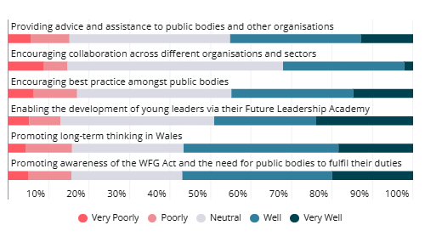

In summary, all six of these questions scored significant net-positive results, the highest of which is ‘Promoting awareness of the WFG Act and the need for public bodies to fulfil their duties’ (Q7). In every category, fewer than 18% of respondents gave a score of ‘poorly’ or ‘very poorly’ in response to any of these phrases. The Commissioner and his team scored particularly well for ‘Promoting long-term thinking in Wales’ with 56% scoring either ‘well’ or ‘very well’.
The lowest scoring point was for ‘Encouraging collaboration across different organisations and sectors’, which also scored a particularly low score for ‘very well’. This could suggest that the Commissioner and his team may need to consider how to better communicate the work in this area.

Priorities and Work Programme
In the next section, respondents were asked how aware they are of the Commissioner’s priorities and work programme, including the Cymru Can Strategy and about how the Commissioner has influenced positive change.

Q8: How aware are you of the Commissioner’s priorities and work programme, including the Cymru Can Strategy? (1 being not aware at all, 5 being very aware)
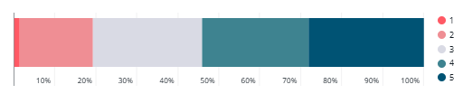

Q9: To what extent has the Future Generations Commissioner or his team influenced positive change in your organisation or sector? (1 being not at all, 5 being very much)
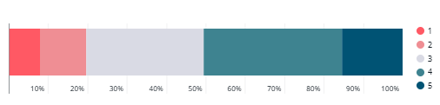

Q10: How useful have you found the guidance and resources provided by the Future Generations Commissioner and his team to support implementation of the Act? (1 being not at all useful, 5 being very useful)
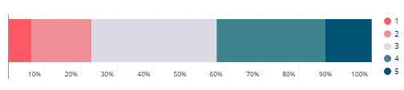

In summary, around 80% of respondents have some awareness of the Commissioner’s priorities and work programme (Q8), and a similar proportion feel that the Commissioner or his team have influenced positive change in their organisation or sector to some degree and have rated at least a three out of five (Q9).
Only 2% gave the lowest score on awareness of the Commissioner’s work, indicating that very few stakeholders have no awareness of the Commissioner’s work (Q8). This should provide some reassurance about the sentiments of organisations across the three sectors about their interaction with the Commissioner and his team.
In terms of the usefulness of the guidance and resources provided by the Commissioner, 75% gave at least a three out of five and only 7% gave the lowest possible score, demonstrating general satisfaction with the resources made available by the Commissioner and his team (Q10).

Additional Support
Respondents were asked what steps the Commissioner and his team could take to help with the application of the Act.
Q11: What further guidance or tools would help you apply the Act more effectively?

Practical Tools and Support
The most popular response to this question is a clear demand for practical, user-friendly tools and direct support. Respondents are seeking resources that facilitate the application of the Well-being of Future Generations Act in their day-to-day work. Many feel that while the principles of the Act are clear, translating them into practical action is challenging without the right tools. They want sector-specific toolkits, templates, and checklists that break down what needs to be done and how to do it, tailored to the realities of their roles—whether in local government, health, or the voluntary sector.
There’s a strong appetite for workshops and interactive sessions, ideally facilitated by the Commissioner’s team or sector experts, to help teams interpret the Act in their own context and move from theory to practice. Respondents also highlight the need for better systems to track progress, with clear definitions and criteria for measuring impact. They want to see practical examples of how others have successfully embedded the Act, and they value opportunities to learn from these real-world experiences. Ultimately, the call is for support that is hands-on, actionable, and relevant to the specific challenges they face.
“As previously, we are in the early stages of developing our response, but we are working with the Commissioner and his team to use some of the tools which are available to develop our next strategic plan, which will more closely encompass the future well-being principles.” (Public Body without duties under the WFG Act)
“It has already begun through Hwb Dyfodol, but further bespoke workshops would be useful in promoting the practical use of the Act further. Also, sector experts, who understand the difficulties of specific sectors (e.g. local authorities) would be useful.” (Welsh Government)
“There needs to be a greater understanding and review of activity tracking tools. Further assistance to identify common definitions and criteria could assist with implementation and recording.” (Local Authority)

Training and Case Studies
There is a strong demand for learning opportunities that go beyond written guidance. Respondents want regular, role-specific training for everyone from councillors to senior leaders, ensuring a consistent understanding of the Act across organisations. They are particularly interested in case studies and best practice examples, such as stories of what has worked (and what hasn’t) in other places, so they can learn from real-world experience rather than abstract principles.
Many would like training to be practical and scenario-based, using real situations to illustrate how the Act can be applied. There’s also a desire for accessible and engaging formats, such as videos, face-to-face sessions, and peer learning opportunities. The underlying message is that people want to see how the Act works in practice, not just in theory, and to have the confidence and skills to apply it themselves. In total, 21 respondents cited training or case studies as their top priority for helping them apply the Act more effectively.
“Guidance for Execs and Chairs” (Health Board)
“Developing skills and knowledge around behaviour change in Wales, ensuring the act is a central part of guides to scrutiny (even where these are developed by others), keep shining a light on interesting case studies. Board members and councillors should undergo regular training. Better guidance on how the act can support sustainable economic growth would also be valuable to the future of Wales.” (Local Authority)
“I've read a lot of it, and I thought the videos and training were very good. I think the team needs to be more visible, engage more with Councils, offer to come visit, and discuss ideas and plans with them. They should also comment on what they are doing, similar to what Llais does. You could also publish best practice examples of Councils making a change and following the Act, or worst practice examples as well, name and shame.” (Other public sector organisation)

Funding and Resources
The third-highest share of responses to this question highlights the need for sustainable, long-term funding and increased capacity. Respondents are frustrated by short-term funding cycles, which make it difficult to plan and deliver meaningful change. They call for multi-year, reliable funding streams that support long-term thinking and prevention, rather than crisis-driven or project-based funding.
Many highlight a lack of staff time, expertise, and organisational capacity, and they want investment in building these capabilities. There’s also a call for funding models that are fair and equitable, particularly for rural areas or sectors facing specific challenges. Some respondents want funding to be more closely aligned with the Act’s goals, supporting collaboration and innovation rather than reinforcing silos. The overall message is that without the right resources, even the best guidance and intentions will struggle to make a difference.
“We would like to see very practical steps & evidence of progress with examples of what can be done to improve wellbeing. From Interlink and our members, we have seen progress with the local authority and WG. WG are stuck with short-term programmes delivered in silos. Unless public services are provided with longer-term funding & programmes that allow them to develop what works locally, it is difficult to see how they can support the community and voluntary sector to support local people and communities to improve wellbeing.” (Voluntary Sector)
“No further guidance or tools necessary, just better partnership structures and proper financing and capacity to support.” (Local Authority)
“I would find more of a regulatory role from the commissioner more effective. When public bodies are facing budget cuts (which they are now), they will sometimes do what is absolutely necessary (as opposed to what is ethically right), and that doesn't always align with the FGA legislation’s intention. At times like this, it would be more effective to have a commissioner who has more power to regulate or 'police' what public bodies are doing and the decisions they're taking.” (Private Sector)

Communication and Visibility
Some 16 respondents say they want the Commissioner’s office to be more visible, accessible, and proactive in its communications. They are seeking regular, targeted updates—newsletters, email briefings, and direct communications tailored to various audiences, ranging from councillors to the general public. There’s a desire for a more substantial presence in the media and on social media, to raise awareness of the Act and share stories of success and learning. Many want the Commissioner’s team to reach out more, visiting councils and communities, offering to discuss ideas and plans, and being available for questions and support. Respondents also emphasise the need for information that is easy to find, understand, and share, including bite-sized summaries and practical examples. The underlying message is that better communication and greater visibility would help build understanding, engagement, and momentum for the Act.
“Far more proactive engagement with Local Authorities and local Councillors, the website is good, but there needs to be regular communications via email to representatives, for example.” (Local Authority)
“Needs to be better and regular communication with MSs, support staff and the public. MSs are best placed to share the Commissioner's work with their constituents, but there needs to be more updates and output from the Commissioner.” (Senedd)
“The good that the FGC does is not shouted about enough, nor is the act. More should go into publicising the good you are trying to achieve and are achieving.” (Local Authority)

Collaboration and Partnerships
There is a strong call for greater and more effective collaboration, both within and across sectors. Six respondents specifically want support to build partnerships between public bodies, voluntary organisations, and the private sector, recognising that many of the Act’s goals can only be achieved by working together.
They highlight the need for increased involvement with town and community councils, as well as for mechanisms that facilitate collaboration, such as stakeholder directories, information-sharing platforms, and support for joint projects.
Many want to learn from successful collaborations elsewhere and to have opportunities to share experiences and challenges. The overall message is that partnership working is essential for effective implementation of the Act and that more support is needed to make it happen in practice.
“More involvement with town and community councils.” (Local Authority)
“Support to improve integration between public bodies, even if it is just a voluntary sign-up service to a directory which gives smart suggestions as to stakeholders who may be interested in a certain project.” (Local Authority)

Legislation and Enforcement
Four respondents want the Act to have more ‘teeth’. They are calling for stronger enforcement powers for the Commissioner, including the ability to investigate, regulate or police public bodies to ensure compliance. Some want clearer consequences for organisations that fail to implement the Act, such as penalties or other accountability mechanisms. Others suggest that the Act itself needs to be reviewed and potentially strengthened to ensure it achieves its intended outcomes. The underlying message is that without effective enforcement, there is a risk that the Act will be ignored or implemented superficially.
“The Commissioner can only work within the legislation, and perhaps the legislation needs strengthening.” (Welsh Government)
“At times like this, it would be more effective to have a commissioner who has more power to regulate or 'police' what public bodies are doing and the decisions they're taking.” (Private Sector)
“The act itself does not achieve its (laudable) intended outcomes, and so a more comprehensive application of it would not lead to benefits. Instead, a repeal of some of the duties, and a strategy instead focused on increasing political pressure to take decisions in the long-term interest would be more effective, potentially through a sustained public information campaign.” (Local Authority)

Functional variance

Public sector respondents, especially from local authorities and health boards, describe the Well-being of Future Generations Act as a guiding framework for planning and reporting, but often highlight challenges such as funding constraints, bureaucracy, and a ‘tick-box’ approach. Local authorities are particularly vocal about the pressures of compliance and the need for practical support, while health boards focus on cross-sector collaboration and equity. There’s a strong call for clearer guidance, more case studies, and better integration of the Act’s principles into everyday practice.

Private sector responses are generally supportive of the Act’s aims but feel more distant from its practical impact. Many view the Act as primarily relevant to public bodies and call for more tailored guidance for businesses. There’s a desire for stronger collaboration with the public sector, clearer examples of business benefits, and recognition of the private sector’s role in sustainable development.

Voluntary sector respondents are positive about the Act and often align their work closely with its principles. However, they express frustration about complex guidance, limited capacity-building, and short-term funding. There’s a strong emphasis on partnership, practical support, and making the Act more relevant to everyday community challenges.

Summary
Some respondents admit to being unsure what would help, or even what the Act is about, highlighting a gap in awareness or engagement. Others express frustration with bureaucracy, describing the Act’s implementation as a ‘tick-box exercise’ or criticising what they see as unnecessary red tape. There are calls for more information in general, with some simply wanting a better understanding of the Act’s purpose and impact. A few responses are more innovative, suggesting the need for new approaches or for the Act to address issues not currently covered.
Respondents most often requested practical, user-friendly tools and direct support to help them apply the Well-being of Future Generations Act in their daily work. There is also a strong desire for regular, role-specific training and real-world case studies, as well as calls for sustainable, long-term funding and increased organisational capacity. Many respondents want clearer, more proactive communication from the Commissioner’s office, as well as better opportunities for collaboration across sectors. A smaller group of respondents called for stronger enforcement powers to ensure the Act is implemented meaningfully.
In response to these findings, the Commissioner might wish to focus on developing and sharing practical resources and toolkits, providing regular and accessible training, and advocating for longer-term, sustainable funding for organisations implementing the Act. Improving communication and visibility, supporting cross-sector partnerships, and reviewing enforcement mechanisms to ensure robust application of the Act would also directly address the main barriers identified by respondents, helping to make the Act more effective.

Further Investigations
In the next section, respondents were asked about what issues they would like to see the Commissioner and his team investigate next. Over two-thirds of respondents completed this open question, offering insight into their suggestions.

Q12: The Commissioner's strongest legislative power is to undertake investigations (under Section 20 of the Act) to consider particular issues in depth and to propose solutions. Public bodies are obliged to participate and respond to those reviews. What sustainable development issues in Wales would you like to see the Commissioner investigate in his next review?

These were the themes that came up most frequently amongst the 137 respondents who provided meaningful responses to this question:

Sustainable Development and Environment
Environmental sustainability, climate resilience, and the circular economy are recurring concerns for around 45 respondents, who want the Commissioner to focus on issues such as pollution, green infrastructure, sustainable transport, and the impact of development on the natural environment.
There is also interest in how the Act can drive innovation in areas like food systems, renewable energy, and nature recovery. This was the theme which came out most strongly from all the responses to this question.
“Well-being economics at local and national level. Practicalities. Opportunities. Drawbacks.” (Local Authority)
“Realising a more circular economy for Wales.” (Voluntary Sector)
“Infrastructure within Wales to provide our communities with food resilience, such as abattoirs (and the loss of them), meat processing points, vegetable processing and infrastructure such as hubs/distribution and co-operative working.” (Local Authority)

Funding and Financial Sustainability
A dominant theme is the challenge of short-term, insecure, or insufficient funding. Respondents repeatedly express frustration that the lack of sustainable financial support undermines their ability to plan and deliver long-term improvements. Over 30 respondents highlight how short-term grants make it challenging to recruit and retain staff, and how the expectation that local bodies will “pick up the tab” after initial funding ends is unrealistic.
There are also calls for a more equitable distribution of resources, especially for rural areas and smaller organisations, as well as for investment in capacity-building. The sense is that, without reliable funding and adequate resources, even the best intentions of the Act cannot be realised.
“Welsh Government provide short-term funding for projects which need to be developed into sustainable services (often pan-Wales) and then expects the HBs to pick up the tab at the end of the funding.” (Health Board)
“Unless public services are provided with longer-term funding & programmes that allow them to develop what works locally, it is difficult to see how they can support the community and voluntary sector.” (Voluntary Sector)
“WG and short-term funding cycles make it very difficult to plan for the long term.” (Voluntary Sector)

Community Cohesion and Social Disparity
A similar proportion of respondents focus on the importance of building cohesive, resilient communities and addressing social inequalities. There is a strong desire for the Act to be utilised as a tool to strengthen local networks and support systems, as well as to address issues such as poverty, social exclusion, and the impact of policy on vulnerable groups.
Some highlight the need for more community engagement and for the Commissioner to investigate how the Act can support attractive, viable, and well-connected communities.
“Social disparity and cohesion.” (Local Authority)
“Cohesive communities – how is the WBFG Act supporting/promoting/galvanising attractive, viable, safe and well-connected communities?” (Voluntary Sector)
“The extent of and breadth of community engagement undertaken by the PSBs.” (Voluntary Sector)

Health and Well-being
A prominent theme is the need to address health inequalities and promote overall well-being, encompassing both physical and mental aspects. Respondents mention the importance of preventative health measures, access to services, and the social determinants of health, such as housing, employment, and environment. There are also calls for more joined-up working between health and social care, and for the Act to be used to drive improvements in population health and resilience.
“Flood resilience.” (Private Individual)
“Collaboration across health and social care services.” (Public Body without duties under the WFG Act)
“Health inequalities and differences in health outcomes across Wales and how they are closely linked to factors such as poverty, housing, and access to services.” (Health Board)

Education, Skills, and Employment
Education, skills, and employment are highlighted as critical levers for achieving the ambitions of the Act and for building a fairer, more prosperous Wales. Respondents repeatedly called for greater investment in education and training, particularly for young people and those from disadvantaged backgrounds. There is a strong desire to see the Act utilised to enhance opportunities for lifelong learning, upskilling, and facilitating transitions into work.
Many respondents emphasised the importance of apprenticeships and vocational training, recognising that not all young people will follow academic routes and that practical skills are essential for both individual and community resilience. The need to support children who are looked after, especially during their transition into work post-16, was also raised as a priority, alongside calls for more support for those facing barriers to employment.
“Skills and employability.” (Local Authority)
“Support for children who are looked after, especially transition into work post-16.” (Local Authority)
“Promotion and support of apprenticeships in all sectors to ensure we do not have a skills gap.” (Private Sector)

Transport and Infrastructure
Transport and infrastructure emerged as a significant concern for around 15 respondents, who see these as foundational to both community well-being and the successful implementation of the Well-being of Future Generations Act. Many participants described the current state of public transport in Wales as “infrequent, unreliable and ridiculously expensive,” highlighting how this undermines efforts to connect communities, reduce social isolation, and support economic development. There is a strong sense that poor transport links limit access to jobs, education, health services, and social opportunities, particularly in rural areas.
Respondents also pointed to the need for investment in active travel infrastructure—such as safe walking and cycling routes—not only to promote healthier lifestyles but also to reduce carbon emissions and congestion. Some called for more innovative approaches, including the development of trams or light railways in cities beyond Cardiff, and a greater focus on sustainable transport solutions that align with the Act’s goals.
“Better transport infrastructure.” (Local Authority)
“Transport and Connectivity.” (Voluntary Sector)
“Public transport in Wales, where I live, is infrequent, unreliable and ridiculously expensive.” (Local Authority)

Policy Implementation and Governance
A smaller group of respondents focus on the effectiveness of the Act’s implementation, the role of public bodies, and the need for stronger governance. They raise concerns about bureaucracy, the “tick-box” nature of compliance, and the need for clearer accountability and enforcement. There are also calls for better integration of the Act’s principles into decision-making and reporting, and for the Commissioner to have more power to regulate or “police” public bodies.
“The mechanism of the Act's implementation appears to have little influence.” (Local Authority)
“My conclusion is that the Act has created a bureaucratic process which does not impact on actual decisions.” (Local Authority)
“The act itself does not achieve its (laudable) intended outcomes, and so a more comprehensive application of it would not lead to benefits.” (Local Authority)

Functional Variance
Respondents from public sector organisations most frequently raised concerns about funding, housing, and the practical challenges of implementing sustainable development, often highlighting the need for long-term planning and stable resources.
A breakdown of public sector organisations illustrates local authority respondents as most concerned about funding, while respondents from health boards are more likely to raise concerns about health inequalities, integration of services and the causes of ill-health
Voluntary sector respondents tended to emphasise community engagement, social inclusion and the importance of collaboration, while also noting persistent inequalities.
Private sector respondents tended to focus on economic development and the role of business in driving sustainability, with less attention given to community or social issues.

Summary
Respondents most frequently raised concerns about short-term funding and the need for sustainable, long-term investment, as well as the financial pressures facing public bodies.
Overall, the data reveals that while all groups are concerned with sustainable development, their priorities and perspectives are shaped by their organisational context and role, leading to distinct thematic focuses in their responses.

Visibility of the Commissioner and his Team

Next, respondents were asked about the visibility of the Commissioner and his team and about where they see and hear from the organisation.

Q13: On a scale of 1 to 5, how visible do you think the Future Generations Commissioner and his team are currently? (1 being not visible at all, 5 being very visible)
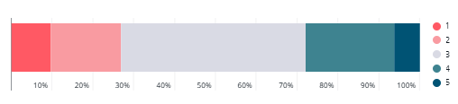

Q14: Where do you see and hear from the Future Generations Commissioner and his team? Tick all that apply.
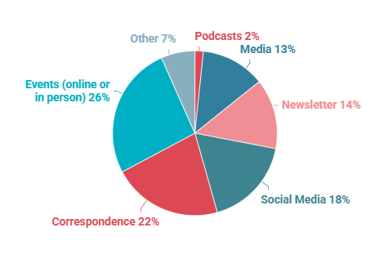

In summary, over 70% of respondents awarded a score of at least three out of five for visibility, while only 10% gave the lowest possible score, indicating a high level of awareness of the Commissioner and the team’s activities (Q13).
Some 33% have seen or heard the Commissioner in either social or more traditional media, which may have room for further growth, as well as the proportion of respondents who receive the Commissioner’s newsletter (Q14).

Conclusion.

The survey responses reveal a complex and nuanced picture of how the Well-being of Future Generations Act is perceived and experienced across Wales.
There is widespread recognition of the Act’s ambition and its potential to drive positive change, with many respondents expressing a strong alignment with its principles and a desire to see Wales lead on sustainable development. However, the data also highlight persistent challenges that limit the Act’s impact in practice.
The survey reveals that the Well-being of Future Generations (Wales) Act is widely recognised as an ambitious and progressive piece of legislation, with strong alignment to its principles across public, voluntary, and private sectors. Many respondents value the Act’s strategic framework, its role in shaping organisational culture, and its emphasis on long-term thinking and collaboration. However, the operational impact of the Act is uneven, and several persistent challenges limit its effectiveness in practice.
Funding and resources are the most frequently cited barriers. Short-term financial cycles and uncertainty over future investment undermine long-term planning and service delivery, particularly in local government, health, and the voluntary sector. Respondents consistently call for sustainable, multi-year funding and increased organisational capacity to support meaningful change.
There is a clear demand for practical, accessible guidance and support. Stakeholders want sector-specific toolkits, case studies, and training that translate the Act’s high-level ambitions into everyday action. Regular workshops, peer learning, and tailored resources are considered essential for developing confidence and skills across all roles.
Community cohesion and social inequality are pressing concerns. Respondents highlight the need for policies that foster resilient, inclusive neighbourhoods, address poverty, and support community-led regeneration. The lack of affordable housing, particularly for young people, is a recurring theme, as is the importance of addressing child poverty and facilitating transitions into employment.
Environmental sustainability is another dominant issue. There is strong support for the Commissioner to focus on climate resilience, biodiversity, green spaces, and the environmental impact of public sector decisions. Respondents want more ambitious action on carbon reduction, sustainable energy, and the management of natural resources.
Health and well-being are closely linked to these themes, with calls for greater integration between health and social care, more preventative approaches, and better support for vulnerable groups. The importance of enabling people to live independently in their communities is emphasised.
Transport and infrastructure feature prominently, with concerns about centralisation of services, the need for improved public transport and connectivity, and the impact on rural and remote areas. Education, skills, and employment are identified as areas where the Act could have a greater influence, particularly in preparing young people for the future workforce.
Awareness and communication of the Act and the Commissioner’s office are generally high; however, a segment of stakeholders remains less engaged or lacks sufficient information. Respondents call for more proactive and targeted communication, as well as greater visibility of the Commissioner’s work.
In conclusion, the survey paints a picture of an Act that is valued and supported in principle, but which requires more practical support, sustainable funding, and a renewed focus on outcomes if it is to fulfil its promise for future generations in Wales.

